IBISWorld Industry Report 56152
July 2019 | Griffin Holcomb

Tour Operators in the US
Touring the landscape: Rising inbound and outbound travel by US residents will boost industry demand

Industry Definition

Businesses in this industry are engaged primarily in assembling and arranging tour packages. This industry also includes travel and wholesale tour operators, which means industry operators may include travel and accommodations within the package of their provided tours. However, businesses that primarily provide accommodations are not included in the industry and travel agencies that sell tour packages, but do not provide the actual tours themselves are not included in this industry.
Back to top

The Supply Chain | Key Economic Drivers  Per capita disposable income  Inbound trips by non-US residents  Domestic trips by US residents  Consumer Confidence Index  Time spent on leisure and sports |  | 
Supply Industries  Amusement Parks  Historic Sites  Hotels & Motels  Museums  National & State Parks  Sightseeing Transportation  Ski & Snowboard Resorts |  | Demand Industries  Travel Agencies
  Tour Operators in the US
Related Industries  Domestic Airlines  Travel Agencies  Hotels & Motels  Sightseeing Transportation |  | Related International Reports  Global Travel Agency Services  Travel Agency and Tour Arrangement Services in Australia  Travel Agencies in China  Tour Operators in the UK  Tour Operators in Canada  Travel Agency and Tour Arrangement Services in New Zealand  Travel Agencies and Tour Operators in Ireland
Back to top

Major Players
Apple Leisure Group |  | Flight Centre Travel Group Ltd.
The Travel Corporation
Back to top

Main Activities

The Primary activities of this industry are:
Arranging and assembling their own tour packages |  | Operating wholesale tours
Operating travel tours

The major products and services in this industry are:
International packaged tours |  | Domestic customized tours
Domestic packaged tours |  | Reservation services
International customized tours |  | Reselling tours
Back to top

Similar Industries
48111b - Domestic Airlines  This industry provides air transportation for passengers and cargo within the United States. |  | 72111 - Hotels & Motels  This industry provides short-term lodging in hotels, motor hotels, resort hotels and motels.
56151 - Travel Agencies  This industry provides trip planning, travel arrangements and sells tour packages and a la carte travel options that compete with tour operators. |  | 48710 - Sightseeing Transportation  The industry provides scenic and sightseeing transportation on land, sea and air.
Back to top

Additional Resources
www.asta.org  American Society of Travel Agents |  | www.ustoa.com  US Tour Operators Association
www.ustravel.org  US Travel Association |  | www.buses.org  American Bus Association
www.ntaonline.com
National Tour Association
Back to top

Industry Jargon
PROCESS MANAGEMENT
A process to administer the flow of data and information for a client.
SYSTEMS MANAGEMENT
Overseeing hardware and software used to automate any kind of data processing service or new processes.
TOUR PACKAGE
A complete trip that can be paid in one lump sum inclusive of costs for fare, accommodation, meals, ground transportation, tour guides and taxes.
Back to top

Glossary
BARRIERS TO ENTRY
High barriers to entry mean that new companies struggle to enter an industry, while low barriers mean it is easy for new companies to enter an industry.
CAPITAL INTENSITY
Compares the amount of money spent on capital (plant, machinery and equipment) with that spent on labor. IBISWorld uses the ratio of depreciation to wages as a proxy for capital intensity. High capital intensity is more than $0.333 of capital to $1 of labor; medium is $0.125 to $0.333 of capital to $1 of labor; low is less than $0.125 of capital for every $1 of labor.
CONSTANT PRICES
The dollar figures in the Key Statistics table, including forecasts, are adjusted for inflation using the current year (i.e. year published) as the base year. This removes the impact of changes in the purchasing power of the dollar, leaving only the "real" growth or decline in industry metrics. The inflation adjustments in IBISWorld’s reports are made using the US Bureau of Economic Analysis’ implicit GDP price deflator.
DOMESTIC DEMAND
Spending on industry goods and services within the United States, regardless of their country of origin. It is derived by adding imports to industry revenue, and then subtracting exports.
EMPLOYMENT
The number of permanent, part-time, temporary and seasonal employees, working proprietors, partners, managers and executives within the industry.
ENTERPRISE
A division that is separately managed and keeps management accounts. Each enterprise consists of one or more establishments that are under common ownership or control.
ESTABLISHMENT
The smallest type of accounting unit within an enterprise, an establishment is a single physical location where business is conducted or where services or industrial operations are performed. Multiple establishments under common control make up an enterprise.
EXPORTS
Total value of industry goods and services sold by US companies to customers abroad.
IMPORTS
Total value of industry goods and services brought in from foreign countries to be sold in the United States.
INDUSTRY CONCENTRATION
An indicator of the dominance of the top four players in an industry. Concentration is considered high if the top players account for more than 70% of industry revenue. Medium is 40% to 70% of industry revenue. Low is less than 40%.
INDUSTRY REVENUE
The total sales of industry goods and services (exclusive of excise and sales tax); subsidies on production; all other operating income from outside the firm (such as commission income, repair and service income, and rent, leasing and hiring income); and capital work done by rental or lease. Receipts from interest royalties, dividends and the sale of fixed tangible assets are excluded.
INDUSTRY VALUE ADDED (IVA)
The market value of goods and services produced by the industry minus the cost of goods and services used in production. IVA is also described as the industry's contribution to GDP, or profit plus wages and depreciation.
INTERNATIONAL TRADE
The level of international trade is determined by ratios of exports to revenue and imports to domestic demand. For exports/revenue: low is less than 5%, medium is 5% to 20%, and high is more than 20%. Imports/domestic demand: low is less than 5%, medium is 5% to 35%, and high is more than 35%.
LIFE CYCLE
All industries go through periods of growth, maturity and decline. IBISWorld determines an industry's life cycle by considering its growth rate (measured by IVA) compared with GDP; the growth rate of the number of establishments; the amount of change the industry's products are undergoing; the rate of technological change; and the level of customer acceptance of industry products and services.
NONEMPLOYING ESTABLISHMENT
Businesses with no paid employment or payroll, also known as nonemployers. These are mostly set up by self-employed individuals.
PROFIT
IBISWorld uses earnings before interest and tax (EBIT) as an indicator of a company’s profitability. It is calculated as revenue minus expenses, excluding interest and tax.
VOLATILITY
The level of volatility is determined by averaging the absolute change in revenue in each of the past five years. Volatility levels: very high is more than ±20%; high volatility is ±10% to ±20%; moderate volatility is ±3% to ±10%; and low volatility is less than ±3%.
WAGES
The gross total wages and salaries of all employees in the industry. The cost of benefits is also included in this figure.

Industry at a Glance

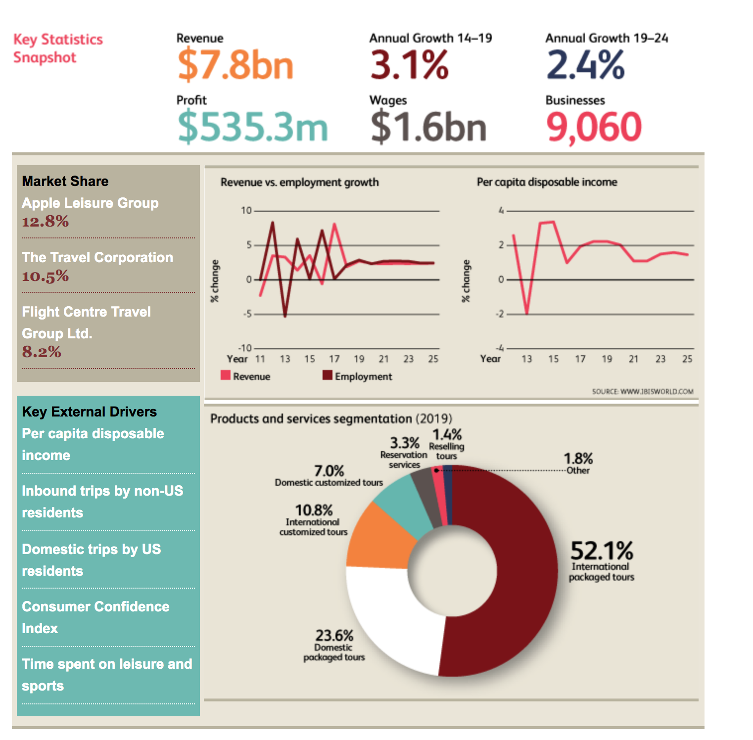

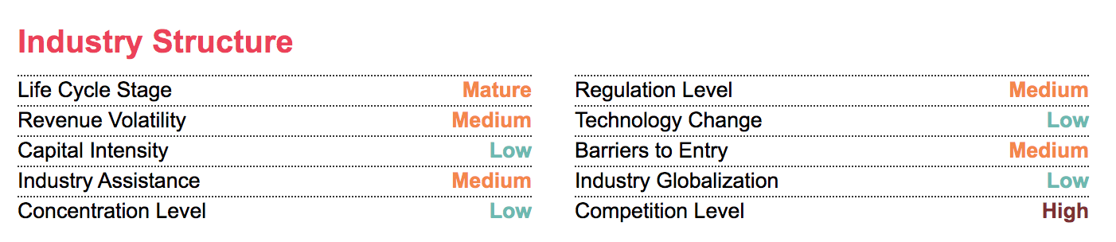

The Tour Operators industry has grown over the past five years to 2019, benefiting from rising disposable income levels and a strengthening global economy. As unemployment declined and consumer spending grew, domestic and international trips taken by US residents increased, driving demand for tour packages. Additionally, inbound trips made by foreigners also grew as disposable income levels rose in countries throughout Asia, Latin America and Europe. Furthermore, the majority of the industry's clients are domestic travelers. As the US dollar has strengthened, it has become less expensive for domestic travelers to venture overseas, which has spurred demand growth for tour operators to package and plan tours in other countries. Consequently, industry revenue is expected to have grown an annualized 3.1% to $7.8 billion over the five years to 2019, including expected growth of 2.7% in 2019 alone.
While the industry has performed well, operators have experienced several challenges. The industry is highly susceptible to political instability, wars and viral outbreaks that can significantly dampen demand for tour packages in specific countries or regions. For instance, instability in the Middle East has limited travel to some war-torn countries due to travel bans set in place. Furthermore, political instability has dampened international travel to places such as Greece. Industry operators have also experienced intensifying competition from mobile applications and websites that help consumers lower travel expenses and plan their own vacation itineraries. As tour operators have sought to compete with online resources, many have lowered prices, resulting in significant price-based competition.
Over the next five years, both domestic and outbound travel by US residents and inbound trips by foreigners are expected to continue increasing, boosting demand for tour packages, and rising profit margins. In addition to increasing travel activity, more consumers are anticipated to seek luxurious travel options as income levels continue to rise. To satisfy growing demand for luxury tour packages and appeal to consumers with other specialized interests, many niche operators are expected to enter the market. Overall, revenue is expected to continue to grow over the next five years, despite increasing external competition from online resources. IBISWorld forecasts industry revenue to increase at an annualized rate of 2.4% to $8.7 billion over the five years to 2024.

Industry Performance

Key External Drivers
Per capita disposable income
Spending on discretionary items, such as those related to travel, depends on disposable income levels. When consumers have more disposable income, they are able to travel more, and spend on tour packages, benefiting the industry. Per capita disposable income is expected to increase in 2019, presenting a potential opportunity for the industry.
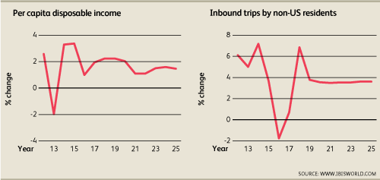
Inbound trips by non-US residents
Many tourists participate in tours as a means of navigating a foreign country. As a result, many foreigners use tour operator services when visiting the United States, particularly those whose native language is not English. When more foreign residents take trips to the United States, tour operators have a larger pool of potential customers. Inbound trips by non-US residents are anticipated to increase in 2019.
Domestic trips by US residents
Nearly one-third of the tour operator business centers on domestic tours. As more Americans travel, demand for tour operators' services increases, lifting industry revenue. The number of domestic trips by US residents is expected to increase in 2019.
Consumer Confidence Index
Changes in consumer confidence have a significant effect on travel intentions, demand and expenditure. Strong consumer confidence helps boost travel, driving demand for industry services. The consumer confidence index is expected to decrease in 2019 posing a potential threat to the industry.
Time spent on leisure and sports
The more leisure time people have, the more likely they are to spend time traveling and going on vacations. Therefore, as people have more time and resources, demand for tour operators' services grows. Time spent on leisure and sports is expected to stagnate in 2019.
Back to top

Current Performance
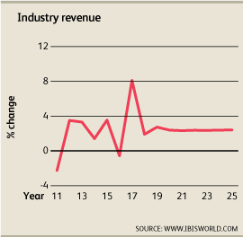
The Tour Operators industry has benefited from rising disposable income levels and a strengthening global economy over the past five years. Due to the discretionary nature of leisure travel, the frequency of travel and the amount consumers spend while traveling largely depend on disposable income. Operators cater to foreign and domestic clients, so as the domestic and global economies have grown, consumers’ disposable income levels and spending have risen. With more money in their pockets, consumers have traveled at rising rates during the period. Consumers indulged in everything from bus tours throughout the United States and luxurious European vacations, to food, beverage and historical tours in cities worldwide, many of which were arranged and booked by industry operators.
However, certain factors have mitigated the growth experienced by industry operators. There has been an influx of online research platforms that have enabled consumers to plan trips on their own. As a result of increased competition from online services and mobile applications that assist consumers with planning for vacations, tour operators have diversified their brand portfolios to better target specific consumer segments, and lowered prices to draw in more customers. Consequently, IBISWorld anticipates industry revenue to have increased an annualized 3.1% to $7.8 billion over the five years to 2019, including expected growth of 2.7% in 2019.
Growth of domestic and international travel
Improving consumer sentiment among Americans has driven demand for travel services in recent years. Lower unemployment, rising disposable income and an improving housing market, among other factors, have boosted consumer confidence. Since traveling requires a significant investment of money and time, the number of trips taken by Americans is largely driven by their confidence in the stability of the economy and its future. Moreover, the consumer confidence index has risen strongly over the past five years, boosting the number of both domestic and international trips made by US residents.
Both domestic and international trips made by US residents have risen since 2014. International trips and domestic trips have grown at annualized rates of 5.0% and 3.6%, respectively, over the five years to 2019. International trips, which are usually more expensive than domestic trips, have grown robustly throughout the five-year period. However, while Mexico and Canada continue to assume the leading outbound destinations for US travelers, travel to Mexico has been relatively tepid because political instability has deterred some travels. However, other foreign locations that have grown in popularity in recent years include Australia, Spain, Iceland and Italy, which all ranked in the most-popular international destinations in 2018, according to the United States Tour Operators Association. Consumers often rely on tour operators to assemble fulfilling tours to countries with which they are not familiar, as tour operators often have extensive knowledge of the destination. As the majority of packaged tours sold by industry operators are international trips, growing demand for foreign travel has significantly boosted industry revenue.
Inbound trips to the United States made by foreigners have also increased over the past five years, further driving industry growth. Visitors from Canada and Mexico continue to make the most international visits to the United States, visitors from the United Kingdom and Japan marked the third- and fourth-largest segments in 2017 (latest available data). In 2017 (latest available data), visitors from China represented 4.2% of total overseas arrivals, South Korea accounted for 3.0% and Germany accounted for 2.7%. Improving disposable income levels in emerging markets have benefited industry operators because foreigners are usually willing to spend more on tours, often purchasing all-inclusive packages. Furthermore, foreigners rely on the convenience of the services that tour companies provide, which ease tourists’ concerns about language and cultural barriers.
Targeting niche consumer segments
The Tour Operators industry remains fragmented, with many small companies providing specific tour packages for different consumer groups and appealing to different preferences and interests. However, the variety of options offered by industry operators has expanded over the past five years as competition to obtain market share has intensified. For example, according to the United States Tour Operators Association, more companies that specialize in tours targeted to specific consumer segments, such as baby boomers and history junkies, have recently entered the industry. Other unique tours that have been introduced in recent years include tours for singles, biking tours throughout Europe and slow tours that specialize in exploring a new area at a more-leisurely pace than most tour packages. As smaller companies have entered the market, the industry expanded. As a result, the number of industry enterprises has increased at an annualized rate of 4.6% over the past five years, totaling 9,060 operators. Similarly, employment has grown at an annualized rate of 2.5% during the same period, totaling 35,674 workers. Additionally, increased demand due to favorable macroeconomic conditions has aided profitability. Over the five years to 2019, profit margins, measured as earnings before interest and taxes, grew from 5.9% of revenue in 2014 to 6.9% in 2019.
Industry challenges
In addition to economic factors, the industry is particularly sensitive to geopolitical instability and actual or threatened terrorism, which can deter people from traveling to certain locations. Since early during the five-year period, significant global health scares, including those associated with severe acute respiratory syndrome, bird flu and the swine flu (H1N1), have dramatically affected travel to certain regions and countries where outbreaks occurred. War and violence can also dampen travel to certain countries; for instance, instability has discouraged potential industry customers from travel to Mexico in recent years.
The industry has also contended with growing competition from mobile applications and online resources that help consumers plan vacations and reduce travel expenses. For example, TripIt is a popular travel organizer that helps people manage flight, hotel and dinner reservations for a trip. Moreover, the proliferation of websites that offer discounted flights, hotels and restaurant deals have placed downward pressure on demand for tour packages as they enable consumers to save on travel costs.
While external competition has grown moderately in recent years, industry operators also compete fiercely against each other. In particular, price competition has risen dramatically due to the introduction of websites that let consumers compare prices charged by different companies. Additionally, travel agents have begun demanding competitive commission rates because of the proliferation of direct online booking and information, reservation and travel payment systems. At the same time, purchase costs have increased over the past five years, driven by higher airfare and hotel costs. Furthermore, as a result of intense competition, operators have sought to retain talented and customer-friendly employees by increasing wages. As a result, the average industry wage increased to $44,804 in 2019.

Revenue Growth
Year | Revenue $ million | Growth %
2005 | 5,165.2 | 0.0
2006 | 5,069.4 | -1.9
2007 | 5,618.7 | 10.8
2008 | 6,561.1 | 16.8
2009 | 5,913.5 | -9.9
2010 | 6,279.3 | 6.2
2011 | 6,138.2 | -2.3
2012 | 6,353.4 | 3.5
2013 | 6,564.0 | 3.3
2014 | 6,656.6 | 1.4
2015 | 6,892.4 | 3.5
2016 | 6,853.3 | -0.6
2017 | 7,409.2 | 8.1
2018 | 7,550.8 | 1.9
2019 | 7,757.6 | 2.7

Back to top
< Industry at a Glance | Industry Outlook >

Industry Outlook
The Tour Operators industry is expected to experience consistent growth over the next five years as domestic and international trips made by Americans and foreigners continue to increase. Improving disposable income levels will likely support this growth, as households spend more on discretionary purchases such as tour packages and vacations. A trend toward premium tours is also anticipated to boost revenue growth as more baby boomers retire and seek luxurious travel options moving forward. Additionally, despite the price-based competition that typified the past five years for operators, growing demand and rising purchase costs will cause prices to inch upward, helping boost industry performance. However, the industry will also be subject to increasing external competition. Consumers, which comprise the largest market for industry operators, will increasingly use online trip planning resources, to the detriment of tour operators. Additionally, online competition will cause travel agents to continue demanding competitive commission rates. However, these factors will not inhibit industry growth. Consequently, industry revenue is expected to grow at an annualized rate of 2.4% to $8.7 billion over the five years to 2024.
Travel growth
Domestic trips taken by US residents are projected to rise, growing an annualized 1.6% over the five years to 2024, representing growth similar to the past five years, broadening the pool of potential industry clients. As Americans’ disposable income is anticipated to rise, residents are expected to travel throughout the United States, visiting places they have never been before. US residents are also anticipated to travel to foreign countries more frequently, with international trips by US residents growing at an annualized rate of 3.2% over the five years to 2024. While popular foreign destinations, such as Australia and Spain, will likely continue to drive growth, more Americans will seek unique experiences at exotic locations. Consequently, outbound trips to Asian countries, particularly China, are expected to expand, as well as trips to Central America. International trips are especially important to the industry, as travelers that have never been to a foreign country rely more frequently on the expertise of tour operators to assemble and plan their tours.
However, demand for tour packages will largely depend on how marketers position travel packages and advertise special promotions. Companies must be mindful of the shifting demographic characteristics of the United States to better target specific consumer groups. For example, as more baby boomers retire over the next five years, demand for travel packages that appeal to retired couples will expand. Also, as the marriage rate has been declining, and is expected to continue to do so, marketers have the opportunity to target single adults and single-parent households. Additionally, visits made by foreigners are also expected to grow moving forward, boosting demand for tours throughout the United States. Inbound trips by non-US residents are expected to rise an annualized 3.5% over the five years to 2024. According to the UN World Tourism Organization, the United States is the leading travel market by revenue in the world.
Premium travel
While greater travel activity is anticipated to boost demand for tour packages moving forward, higher disposable income is expected to drive demand for luxury tour packages. According to research conducted by TripAdvisor, consumer interest in green initiatives undertaken by hotels and luxury travel is expected to grow. Demand for luxury air travel is also anticipated to expand as the global economy strengthens. As a result, IBISWorld expects more niche, premium tour operators to enter the market over the next five years. Additionally, leading industry companies are expected to offer luxury tour packages to appeal to a consumer segment that seeks door-to-door services, business-class travel and the best restaurant meals a city has to offer. For instance, Insight Vacations, a premium tour operator, recently added seven new luxury itineraries and one new premium tour to their holiday tour options in response to the growing demand for luxurious excursions. Additionally, The Travel Corporation operates several brands dedicated exclusively to luxury travel, such as Luxury Gold and Grand European Travel. The growing popularity of premium tour packages will help boost industry revenue growth and improve profitability. As premium packages and specialized tours become more popular, new companies will begin to enter the industry; accordingly, the number of industry enterprises is expected to grow at an annualized rate of 2.7% over the five years to 2024, totaling 10,351 operators. As specialized tours become more popular, operators will grow to rely on more highly skilled workers. As a result, average wages will likely grow as well. Over the next five years, wages are expected to grow at an annualized rate of 2.5%, totaling $1.8 billion. Wages are expected to grow in line with revenue, which should lead to stagnant profit margins. Overall, profit is expected to decrease marginally, and account for 6.8% of revenue in 2024.
Revenue Outlook
Year | Revenue $ million | Growth %
2020 | 7,943.1 | 2.4
2021 | 8,128.5 | 2.3
2022 | 8,321.7 | 2.4
2023 | 8,518.0 | 2.4
2024 | 8,722.1 | 2.4
2025 | 8,931.8 | 2.4
Back to top

Industry Life Cycle
This industry is mature More Info
The Tour Operators industry is in the mature phase of its industry life cycle. This industry exhibits several characteristics of a mature industry, including clearly defined market segments, accepted products and services and larger companies acquiring smaller operators to boost market share. Over the 10 years to 2024, industry value added (IVA), which measures an industry’s contribution to the economy, is projected to increase at an annualized rate of 2.8%. While US GDP is expected to grow at an annualized rate of 2.0% during the same period. Even though faster than annualized growth than GDP is characteristic of a growing industry, the Tour Operators industry’s product offerings and consumer based has not changed drastically during the five-year period.
As the industry stabilized, operators are expected to experience higher competition. Due to the intensifying competition among tour operators, merger and acquisition activity is expected to accelerate as companies seek cost savings from economies of scale and grow market share. The markets that this industry sells to are clearly defined. Downstream travel agents, businesses and private citizens have long-been the largest downstream markets for operators. Older individuals have tended to travel more, as a result of increased income and leisure time, and even as younger individuals have sought out travel opportunities, the age segmentation of individuals that buy from this industry has largely stayed the same. Many smaller operators opened in an effort to appeal to those with specialized interests, such as food, beverage and historical tours. Larger companies will likely acquire these smaller businesses to expand their client portfolios and increase market share. As a result, concentration is anticipated to increase over the five years to 2024, which is common among mature industries.
